**Active Learning for Computer Vision Curriculum**

**Project 9 Solution: Active Learning Variants**

**Total Points Possible: 50**

**Problem 1 (25 points)**

A sample output is shown below. The correct answer should resemble this output.

**Note**: this graph is from the paper by Joshi et al. (discussed in the lecture material). This experiment was conducted on a different dataset with different training, unlabeled and test splits. Thus, the output on the VidTIMIT dataset may not exactly match this output. This should just be used as a reference.

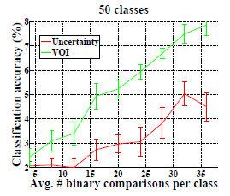

**Problem 2 (25 points)**

There can be many answers to this problem. One possible answer is in the case of counting the number of objects (pedestrians) in an image. This is a regression problem and to annotate a data sample in this application, a human oracle needs to count the number of objects in each image. This can be extremely time consuming and labor intensive. An alternate strategy to provide annotation is to select two (or more) images and order them in increasing number of objects in them. This is a much easier way of user interaction as the human oracle need not count the explicit number of objects in an image, but only needs to provide a rank ordering of a selected set of images.